5th Grade Lessons Table of Content

Unit I: Food Webs
Page(s)

Science Activity 1: Food Webs………………………………. 1
Science Activity 2: Mexican Gray Wolves-
A Docent Classroom Visit………………..2
Language Arts Activity 1: Fact or Opinion………………….3
Fact or Opinion Worksheet………….…..4

Unit II: Predator and Prey

Science Activity 1: Predator and Prey………………….…….5
Science Activity 2: Predator and Prey Field Trip…………..6,7
Math Activity 1: Predator, Predator and Prey, Prey
Venn Diagram…………….………………....8
Venn Diagram Worksheet……………….…9
Math Activity 2: Finding Fractions and Converting
to Fractions to Decimals to Percents……...10
Math Activity 3: Wolf Graph………………………………....11
Language Arts Activity: Bias and Stereotyping……………..12
Language Arts Activity: Write a “Big Bad Wolf”
Paragraph…………………………13
Language Arts Activity: Compare and Contrast……………14
Math Activity 4: The Three Little Javelinas and

The True Story of The Three Little Pigs
By A. Wolf Venn Diagram………………...15
Venn Diagram Worksheet………………….16
Language Arts Activity 4: Writing a Letter to A. Wolf…...…17

Unit III: Animal Adaptations

Science Activity 1: Animal Adaptations- Time of
Activity…………………………..18,19
Science Activity 2: CSI: Who Killed the Rabbit?
Docent Classroom Visit………….20

5th Grade Lessons Unit I: Food Webs Page 1

Science Activity 1: Food Webs

Strand II: Content of Science
Standard II: (Life Science) Understand the properties, structures, and processes of living things and the
interdependence of living things and their environments.
5-8 Benchmark 1: Explain the diverse structures and functions of living things and the complex relationships
between living things and their environments.
5th Grade Performance Standards: 2 Understand how food webs depict relationships between different
organisms.

Objective: The students will place picture cards of Chihuahuan Desert plants and animals in proper order to complete food chains and food webs.

Materials:
“A Chihuahuan Desert Food Web” PowerPoint.
Pictures of Chihuahuan Desert plants and animals from the “Food Chain/Food Web” packet.
Plants and Animals of the Chihuahuan Desert” booklet, and arrows from the “Food Chain/Food Web” packet.

Procedure:
Show and discuss the PowerPoint “A Chihuahuan Desert Food Web.” Hand out the “Food Chain/ Food Web” packets. Instruct the students to use the booklet to help them create food chains and food webs. The arrow’s point should be pointed to the animal that is doing the eating.

Answers will vary.

5th Grade Lesson Unit I: Food Webs Page 2

Science Activity 2: Mexican Gray Wolves
Living Desert Zoo and Gardens State Park Docent Classroom Visit Activity

Strand II: Content of Science
Standard II (Life Science): Understand the properties, structures, and processes of living things and the
interdependence of living things and their environments.
5-8 Benchmark II: Understand how traits are passed from one generation to the next and how species evolve.

Performance Standards
2. Identify characteristics of an organism that are inherited from its parents (e.g., eye color in humans, flower
color in plants) and other characteristics that are learned or result from interactions with the environment.

Objective: The students will become familiar with major characteristics of wolves, some of their adaptations, and their niche in the food chain/food web.

A docent from the Living Desert Zoo and Gardens State Park presents this activity. This activity includes a wolf power point and the chance for students to see and touch a Mexican gray wolf skull. The docent will also bring a wolf mask pattern that the teacher may use at a later date. The activity takes about 50 minutes. Since a lot of emphasis is placed on wolves thought out the 5th grade lessons, you may find this activity very useful. The students should have completed the “Food Web” science activity before the docent comes. If you wish to have a docent bring this activity to your classroom, please call the park at (575) 887-5516.

5th Grade Lessons Unit I: Food Webs Page 3

Language Art Activity 1: Fact or Opinion

STRAND 1: Reading and Listening for Comprehension
Content Standard 1: Students will apply strategies and skills to comprehend information that is read, heard,
and viewed.
5-8 Benchmark 1-C Apply critical thinking skills to analyze information.
5th Grade Performance Standards
- Distinguish between fact and opinion.

Objective: The student will determine if a statement is a fact or an opinion.

Materials:
Wolf Fact or Opinion Worksheet

Procedure:
Discuss what makes a statement a fact or an opinion. Give the students some examples, and then have the students give a few examples. Have students complete the Wolf Fact or Opinion Worksheet.

Answers
- O
- F
- F
- F
- O
- F
- F
- O
- F
10. O

Page 4

Wolf Fact or Opinion Worksheet Name_______________________________

Place an F on the line if the statement is a FACT.
Place an O on the line if the statement is an OPINION.

________1. Wolves are beautiful animals.

________2. Wolves are carnivores.

________3. During the winter, wolves have two types of fur- outer fur that helps
keep them dry and inner fur that helps keep them warm.
________4. Wolves have canine teeth.

________5. Wolves are dangerous animals, and people should kill all of them.

________6. Wolf pups have blue eyes when they are born.

________7. Wolves that live in the wilderness eat mostly elk and deer.

________8. People should leave wolves alone and not bother them.

________9. An adult wolf can eat about 20 pounds of meat at one time.

________10. Wolf pups are cute.

5th Grade Lessons Unit II: Predator and Prey Page 5

Science Activity 1: Predator and Prey

Strand II: Content of Science
Standard II (Life Science): Understand the properties, structures, and processes of living things and the
interdependence of living things and their environments.
5-8 Benchmark 1: Explain the diverse structures and functions of living things and the complex relationships
between living things and their environments.

Performance Standards
1. Identify the components of habitats and ecosystems (producers, consumers, decomposers, predators).

Objective: The students will identify Chihuahuan Desert animals as predators or prey using the physical adaptation characteristics of the animals.

Materials:
“Predator-Prey” PowerPoint
Pictures from the “Food Chain/ Food Web” packets
“Plants and Animals of the Chihuahuan Desert” booklet in “Food Chain/ Food
Web” packets
2 per group 8 ½ x 11” papers- the first one with “Predator” written on it, the second one with “Prey” written on it

Procedure:
Show and discuss the “Predator-Prey PowerPoint.

Hand out the “Food Chain/ Food Web” packets. Write the following list of animals on the board:

badger kangaroo rat
black bear kit fox
black-chinned hummingbird mice/rats
bobcat mountain lion
coyote mule deer
desert cottontail rabbit prairie dog
elk pronghorn
golden eagle raccoon
great horned owl red-tailed hawk
javelina ringtail
scaled quail

Continued on the next page

5th Grade Lessons Unit II: Predators and Preys Page 6

Science Activity 1: Continued

Have the students pull out the pictures of the animals that are listed on the board. Instruct them to look at the pictures and place them on the correct papers that are labeled: “Predators” and “Prey.” They may use the “Plants and Animals of the Chihuahuan Desert” booklets. Tell the students that in this exercise, animals that eat other animals are predators even if some of them can become prey to other predators.

Answers:
Prey: Predators:
Black-chinned hummingbird badger
desert cottontail rabbit black bear
elk bobcat
javelina coyote
kangaroo rat golden eagle
mice/rats great horned owl
mule deer kit fox
prairie dog Mexican gray wolf
pronghorn mountain lion
scaled quail raccoon
red-tailed hawk
ringtail

5th Grade Lessons Unit 2: Predator and Prey Page 7

Science Activity 2: Predator and Prey
Living Desert Zoo and Gardens State Park Field Trip:

Strand II: Content of Science
Standard II (Life Science): Understand the properties, structures, and processes of living things and the
interdependence of living things and their environments.
5-8 Benchmark 1: Explain the diverse structures and functions of living things and the complex relationships
between living things and their environments.

Performance Standards
- Identify the components of habitats and ecosystems (producers, consumers, decomposers, predators).

Objective: The students will identify Chihuahuan Desert animals as predators or prey using the physical adaptation characteristics of the animals.

We have a “Predator-Prey Activity Page” that the students can complete as they walk through our park. They will be able to personally see the animals and use the eye and foot clues to determine if the animals are predators or prey. Please call the park at (575) 887-5516 so we can have the papers available when you arrive. You may also request to have a docent take your class through the park. We will do our best to provide one.

5th Grade Lessons Unit II: Predator and Prey Page 8

Math Activity 1: Predator, Predator and Prey, Prey Venn

Diagrams

Strand: DATA ANALYSIS AND PROBABILITY

Standard: Students will understand how to formulate questions, analyze data, and determine probabilities.
5-8 Benchmark D.1: Formulate questions that can be addressed with data and collect, organize, and display
relevant data to answer them.
Performance Standard: Grade 5
5.D.1.2 Construct, interpret, and analyze data from graphical representations and draw simple conclusions using
bar graphs, line graphs, circle graphs, frequency tables, and Venn diagrams.

Objective: Students will use a Venn diagram to correctly place Chihuahuan Desert animals in three categories.

Materials:
Venn diagrams with Predators, Predator and Prey, and Prey titles

Procedure:
Give each student a Venn diagram form.
Place these animals’ names on the board:

bobcats mountain lions (adults)
coyotes mule deer
desert cottontail rabbits red-tailed hawk
desert tarantulas roadrunners
golden eagles snakes

Let the students use their “Plants and Animals of the Chihuahuan Desert” booklets to fill in the Venn diagram.

Answers:

Predators Both Predators Prey
and Prey
golden eagle bobcat desert cottontail rabbits
mountain lions coyote mule deer
red-tailed hawk desert tarantulas
roadrunner
snakes
Note: Students will need the completed Venn diagram when they do Unit II, Math Activity 2 and Unit II, Language Arts Activity I.

Page 9
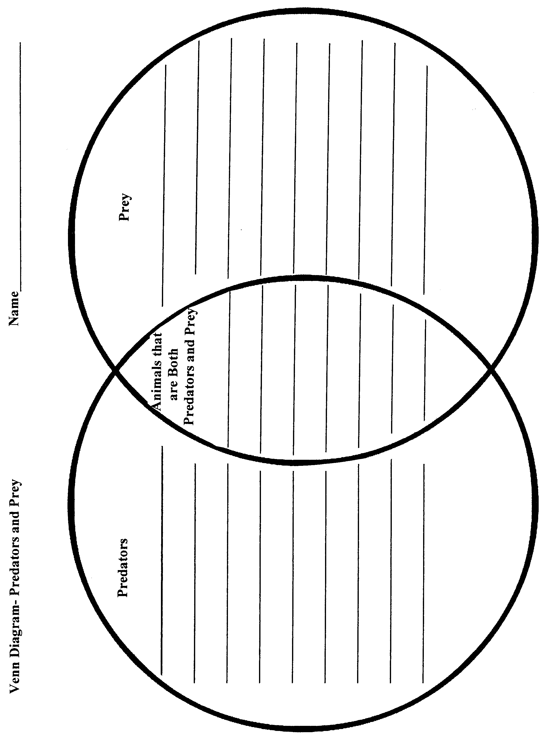

5th Grade Lessons Unit II: Predator and Prey Page 10

Math Activity 2: Finding Fractions and Converting the Fractions to Decimals and Percents

Strand: NUMBER AND OPERATIONS
Standard: Students will understand numerical concepts and mathematical operations.
Benchmark N. 1: Understand numbers, ways of representing numbers, relationships among numbers, and
number systems.
Performance Standards: Grade 5
5.N.1.4 Interpret percents as part of a hundred (i.e., find decimal and percent equivalents for common
fractions, explain how they represent the same value, and compute a given percent of a whole
number).

Objective:
Using the information from their Venn diagrams, the students will write the fraction, percent, and equivalent decimal of the animals that are prey, predator and prey, and predators.

Materials:
Completed Venn diagram from Unit II, Math Activity 1

Procedure:
Have students write the fraction for each of the three categories from their Venn diagrams. Once they have written the fractions have them write the equivalent percent and decimal of each fraction.

Answers:
Predators – 3/10, 30%, 0.30
Both Predators and Prey - 5/10, 50%, 0.50
Prey - 2/10, 20%, 0.20

5th Grade Lessons Unit II: Predator and Prey Page 11

Math Activity 3: Wolf Graph

Strand: DATA ANALYSIS AND PROBABILITY
Standard: Students will understand how to formulate questions, analyze data, and determine probabilities.
5-8 Benchmark D.1: Formulate questions that can be addressed with data and collect, organize, and display
relevant data to answer them.
Performance Standards
5.D.1.1 Construct, read, analyze, and interpret tables, charts, graphs, and data plots.
5.D.1.2 Construct, interpret, and analyze data from graphical representations and draw simple conclusions using
bar graphs, line graphs, circle graphs, frequency tables, and Venn diagrams.

Objective: The students will make a graph with information they have gathered and tallied.

Materials:
Paper for making graphs

Procedure: Have the students vote on “I like wolves” or “I don’t like wolves.” They should use tally marks to record the votes. Have them make a graph either on the computer or on paper to show the results of the vote.

Note: Students will need the completed Wolf Graph when they do Unit II, Language Arts Activity 1.

5th Grade Lessons Unit II: Predator and Prey Page 12

Language Arts Activity 1: Bias and Stereotyping

STRAND 1: Reading and Listening for Comprehension
Content Standard 1: Students will apply strategies and skills to comprehend information that is read, heard,
and viewed.
5-8 Benchmark 1-C Apply critical thinking skills to analyze information.
5th Grade Performance Standards
4. Make informed judgments about bias, propaganda, stereotyping, and media techniques.

Strand II: Writing and Speaking for Expression
Content Standard II: Students will communicate effectively through speaking and writing.
5-8 Benchmark II-A: Use speaking as an interpersonal communication tool.
5th Grade Performance Standards
2. Use language to:
b. evaluate information and ideas;
c. present and support arguments; and
d. influence the thinking of others

Objective: Students will recognize that authors can use stereotyping and bias to sway opinions and then verbally express their own ideas about wolves.

Materials:

Completed Venn diagram from Unit II, Math Activity 3“Wolf Graph”
A traditional story of The Three Little Pigs

Procedure: After reading a traditional story of The Three Little Pigs, discuss how the author makes people feel about wolves and pigs. Discuss how the author’s stereotyping of wolves might have an affect on what people think about wolves. Using the graph the students completed in Math Activity 3, look at the attitudes of the students. Ask if the ones that had voted that they didn’t like wolves wish to share why they feel the way they do. The teacher should share with the students that there have been no known cases of a wolf attacking people and that wolves are actually afraid of people. After discussing these facts, students can share their feelings about wolves again. You might want to have the students vote again on whether they like wolves or not.

5th Grade Lessons Unit II: Predator and Prey Page 13

Language Arts Activity 2: Writing a “Big Bad Wolf”
Paragraph

Strand II: Writing and Speaking for Expression
Content Standard II: Students will communicate effectively through speaking and writing.
5-8 Benchmark II-B: Apply grammatical and language conventions to communicate
5th Grade Performance Standards
- Write sentences that use:
  - independent and dependent clauses;
  - transitions; and
  - conjunctions to connect ideas.
- Identify and correctly use verbs that are often misused.
- Use colons and quotation marks correctly.
- Spell most commonly used words accurately using a multi-strategy approach to learn new spellings.
5. Edit final products for grammar, language conventions, and format.

Strand II: Writing and Speaking for Expression
Content Standard II: Students will communicate effectively through speaking and writing.
5-8 Benchmarks II-C: Demonstrate competence in the skills and strategies of the writing process.
5th Grade Performance Standards
2. Apply writing process through:
- pre-writing;
- creating a rough draft;
- revising for clarity of thought and focused communication;
- editing; and publishing and sharing of final product.

Objective: The students will write a properly punctuated, grammatically correct paragraph supporting their ideas of whether they think the “Big Bad Wolf” is really “bad.”

Materials: Copy(ies) of The True Story of the Three Little Pigs by A. Wolf
by Jon Scieszka
Procedure:
Read to the students, or have them read The True Story of the Three Little Pigs by A. Wolf. Discuss what wolves eat in the wild and that they are carnivores. Have the students write a paragraph telling if they think the “Big Bad Wolf” really is “bad.” They need to support their reason(s).

5th Grade Lessons Unit II: Predator and Prey Page 14

Language Arts Activity 3: Compare and Contrast The Three Little Javelinas and The True Story of the Three Little Pigs by A. Wolf

STRAND 1: Reading and Listening for Comprehension
Content Standard 1: Students will apply strategies and skills to comprehend information that is read, heard,
and viewed.
5-8 Benchmark 1-A Listen to, read, react to and interpret information
5th Grade Performance Standards
- Make connections between texts by recognizing similarities and differences based on a common theme,
lesson, or message.
STRAND 1: Reading and Listening for Comprehension
Content Standard 1: Students will apply strategies and skills to comprehend information that is read, heard,
and viewed.
5-8 Benchmark 1-C Apply critical thinking skills to analyze information.
5th Grade Performance Standards
- Respond to fiction, non-fiction, poetry, and drama using interpretive, critical, and evaluation processes
by:
d. examining alternative perspectives.
- Analyze cause and effect relationships, compare and contrast information, facts, characters, and objects
to predict a logical outcome.
Strand III: Literature and Media
Content Standard III: Students will use literature and media to develop an understanding of people, societies, and the self.
5-8 Benchmarks III B: Identify ideas and make connections among literary works.
5th Grade Performance Standards
2. Contrast the actions and motives of characters in literary works.

Objective: The students will compare and contrast The Three Little Javelinas and The True Story of the Three Little Pigs by A. Wolf.

Materials: Copy(ies) of The Three Little Javelinas by Susan Lowell

Copy(ies) The True Story of the Three Little Pigs by A. Wolf
by Jon Scieszka

Procedure: Read or have students read The Three Little Javelinas and The True Story of the Three Little Pigs by A. Wolf. Discuss the two stories and what is the same and different about them.

5th Grade Lessons Unit II: Predator and Prey Page 15

Math Activity 4: The Three Little Javelinas and The True Story of the Three Little Pigs by A. Wolf Venn Diagram

Strand: DATA ANALYSIS AND PROBABILITY
Standard: Students will understand how to formulate questions, analyze data, and determine probabilities.
5-8 Benchmark D.1: Formulate questions that can be addressed with data and collect, organize, and display
relevant data to answer them.
5.D.1.2 Construct, interpret, and analyze data from graphical representations and draw simple conclusions using bar graphs, line graphs, circle graphs, frequency tables, and Venn diagrams.

Objective: Students will use a Venn diagram to correctly place information from the books: The Three Little Javelinas and The True Story of the Three Little Pigs by A. Wolf into three categories.

Materials: Copy(ies) of The Three Little Javelinas by Susan Lowell
Copy(ies) The True Story of the Three Little Pigs by A. Wolf
by Jon Scieszka
Copies of the Venn diagram: Comparing Stories

Procedure: After students have read and compare and contrasted the two stories, have them place information under each of the three categories on the Venn diagram.

Answers: Accept reasonable answers, such as:

The Three Little Javelinas:

Pigs lived in a tumbleweed house, an adobe house, and a saguaro sticks.
Has a coyote instead of a wolf
The pigs were not eaten

It tells why the coyote howls
The coyote gets its tail burned
They live in the Sonoran Desert

Both Stories:
Had three pigs
the pigs’ houses were blown down

The True Story of the Three Little Pigs by A. Wolf:
Has a wolf instead of a coyote
Told by the wolf (point of view)
Wolf was put in jail

Wolf claimed he was innocent

Page 16

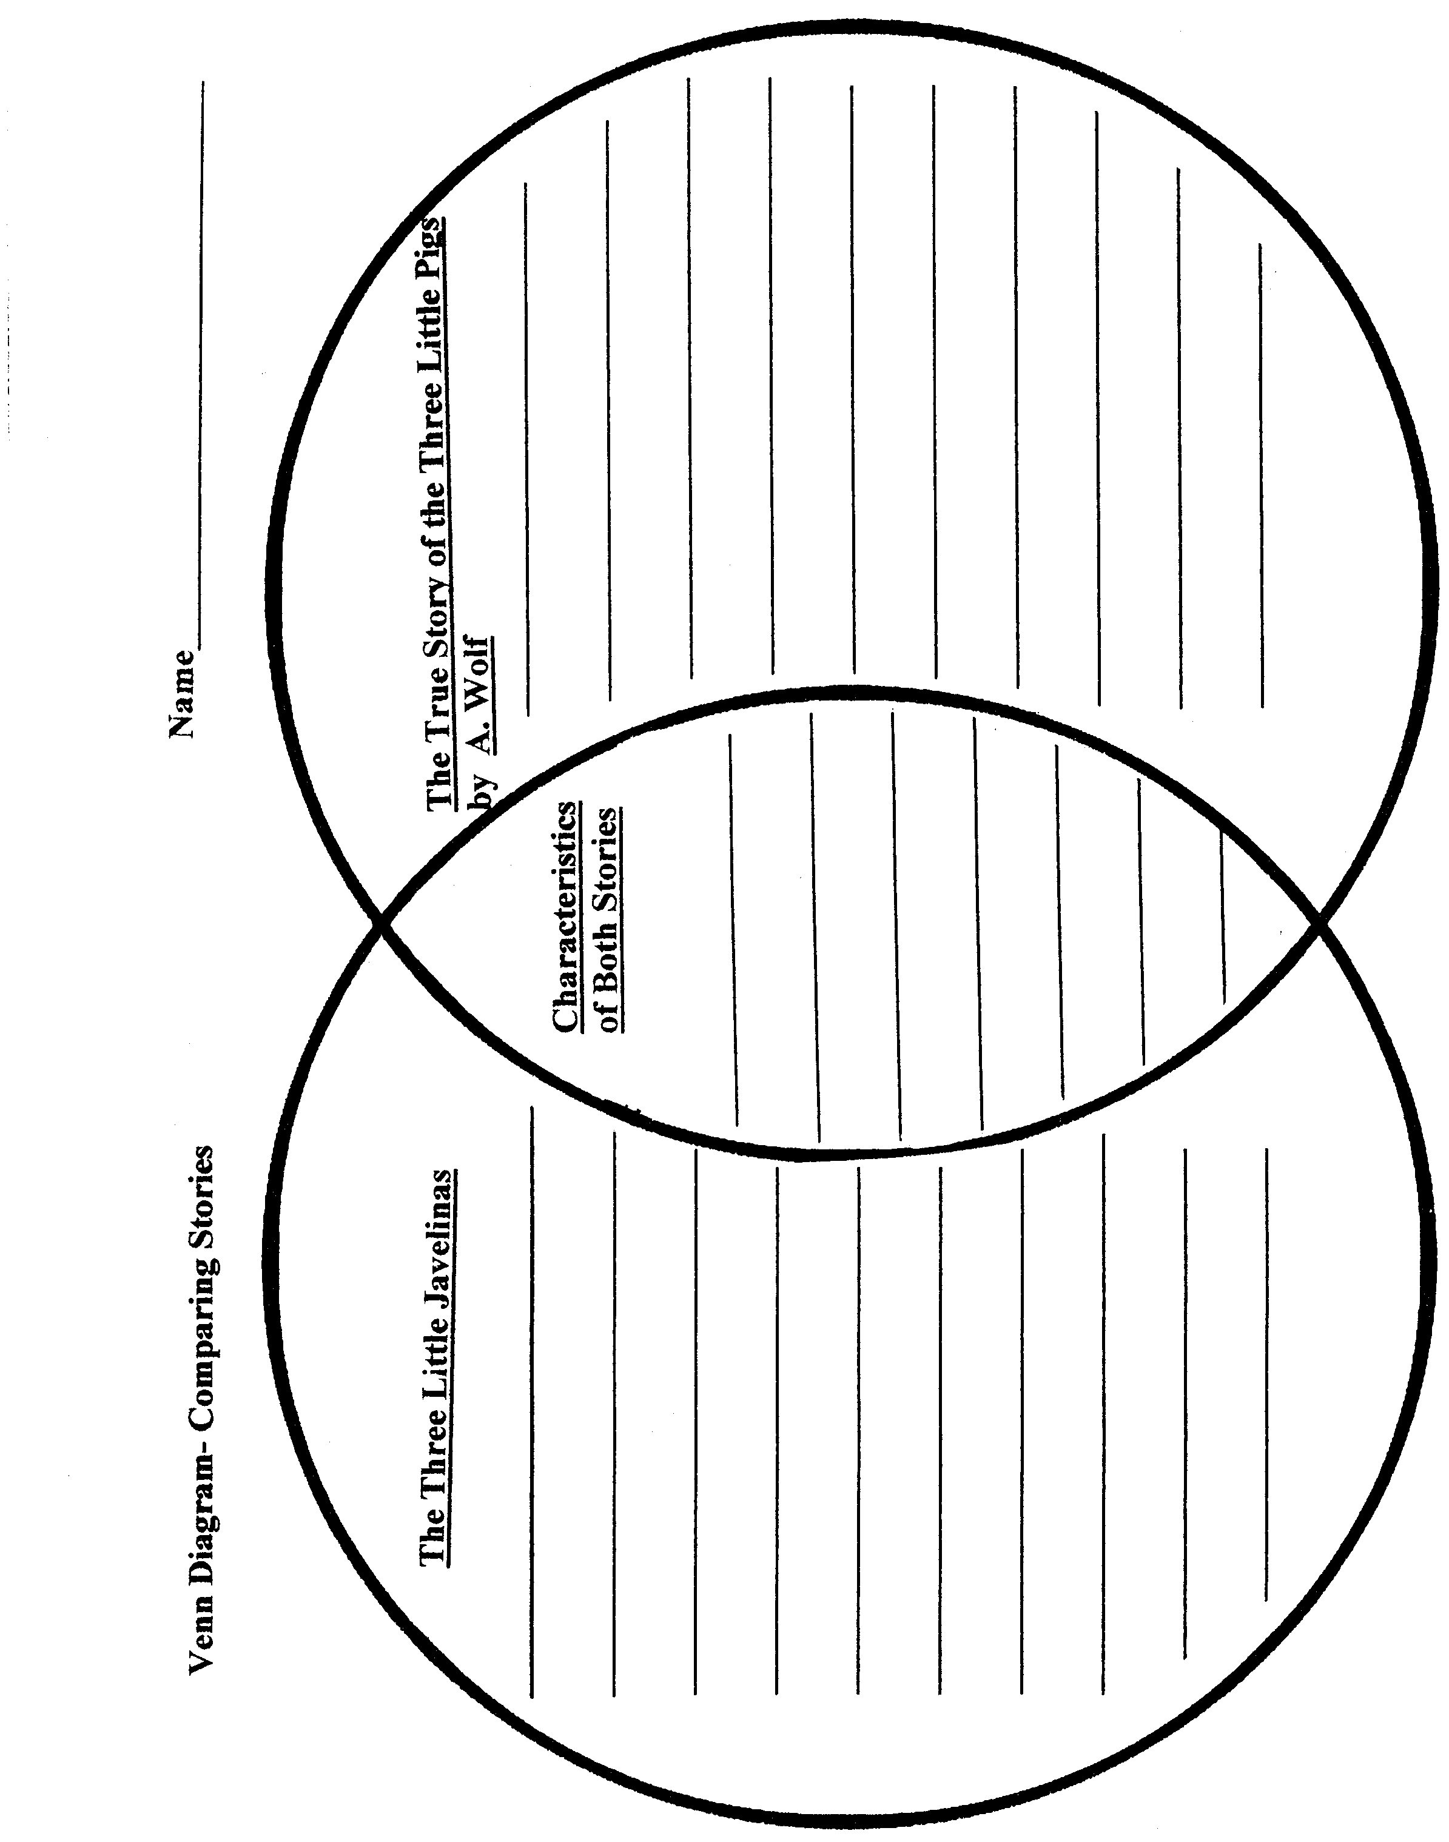

5th Grade Lessons Unit II: Predator and Prey Page 17

Language Arts Activity 4: Writing a Letter to A. Wolf

STRAND 1: Reading and Listening for Comprehension
Content Standard 1: Students will apply strategies and skills to comprehend information that is read, heard,
and viewed.
5-8 Benchmark 1-A Listen to, read, react to and interpret information
5th Grade Performance Standards
- Listen actively and critically by:
  - asking questions
  - delving deeper into the topic
  - elaborating on the information and the ideas presented
  - evaluating information and ideas
  - making inferences and drawing conclusions
  - making judgments
Strand II: Writing and Speaking for Expression
Content Standard II: Students will communicate effectively through speaking and writing.
5-8 Benchmark II-B: Apply grammatical and language conventions to communicate
5th Grade Performance Standards
- Write sentences that use:
  - independent and dependent clauses;
  - transitions; and
  - conjunctions to connect ideas.
- Identify and correctly use verbs that are often misused.
- Use colons and quotation marks correctly.
- Spell most commonly used words accurately using a multi-strategy approach to learn new spellings.
5. Edit final products for grammar, language conventions, and format.

Strand II: Writing and Speaking for Expression
Content Standard II: Students will communicate effectively through speaking and writing.
5-8 Benchmarks II-C: Demonstrate competence in the skills and strategies of the writing process.
5th Grade Performance Standards
2. Apply writing process through:
- pre-writing;
- creating a rough draft;
- revising for clarity of thought and focused communication;
- editing; and
- publishing and sharing of final product.
3. Create journals, notes, stories, reports, and letters using appropriate formats and multimedia technologies
to communicate to an audience for a specific purpose.

Objective: The students will write a properly punctuated, grammatically correct, properly formatted, and well-composed letter.

Materials: Copies of The True Story of the Three Little Pigs by A. Wolf

Procedures: Discuss that The True Story of the Three Little Pigs by A. Wolf is told from the wolf’s point of view. Have the students think about what the wolf was saying and if they were or were not convinced by his version of the story. Do they think the wolf seems trustworthy? Have students write a letter to A. Wolf in jail. Have them tell the wolf if they believe the wolf’s story or not. Have them give reasons for their beliefs.

5th Grade Lessons Unit III: Animal Adaptations Page 18

Science Activity 1: Animal Adaptations - Time of Activity

Strand II: Content of Science
Standard II (Life Science): Understand the properties, structures, and processes of living things and the
interdependence of living things and their environments.
5-8 Benchmark II: Understand how traits are passed from one generation to the next and how species evolve.

Performance Standards
2. Identify characteristics of an organism that are inherited from its parents (e.g., eye color in humans, flower
color in plants) and other characteristics that are learned or result from interactions with the environment.

Objective: The students will identify some physical and behavioral characteristics of Chihuahuan Desert animals.

Materials:
“Time of Activity” PowerPoint
One large sheet of construction paper for each group (2-3 students)
Pictures from “Food Chain/ Food Web” packets
“Plants and Animals of the Chihuahuan Desert” booklets from their packets

Procedure:
Show and discuss “Time of Activity” PowerPoint.
Discuss that the animals’ time of activity is a behavioral adaptation and that some of the animals change their time of activity when the seasons change. Some animals, like snakes, frogs, and turtles may hibernate during the cold winter.
Hand out the “Food Chain/ Food Web” packets to each group.
Hand out a large sheet of construction paper to each group.
Have the students divide the paper into thirds and head them with:

Time of Activity
Nocturnal Crepuscular Diurnal

Tell the students to use their “Plants and Animals of the Chihuahuan Desert” booklets to determine which animals belong under each category. They should place the pictures from their “Food Chain/ Food Web” packets under the correct category. Tell them that animals that have different times of activity can be placed in whichever category they select. You can have the groups write their answers on a piece of paper if you want to grade their work.

The answers are on the next page.

5th Grade Lessons Unit 3: Animal Adaptations Page 19

Science Activity 1: Continued
Answers:

Nocturnal Crepuscular Diurnal
badger black bear badger
bobcat bobcat black bear
coyote coyote coyote

desert cottontail rabbit desert cottontail rabbit elk
hog-nosed skunk elk golden eagle
kangaroo rat javelina javelina
kit fox kit fox mule deer
mice/rats Mexican grey wolf prairie dog
mountain lion mountain lion pronghorn
porcupine mule deer red-tailed hawk
pronghorn porcupine roadrunner
raccoon scaled quail snakes
ringtail snakes turkey vulture
snakes (in summer) whiptail lizard

5th Grade Lessons Unit III: Animal Adaptations Page 20

Science Activity 2: Classroom Visit
Living Desert Zoo and Gardens State Park Docent Classroom Activity: CSI: Who Killed the Rabbit?

Strand: II: Content of Science

Strand II: Content of Science
Standard II (Life Science): Understand the properties, structures, and processes of living things and the
interdependence of living things and their environments.
5-8 Benchmark II: Understand how traits are passed from one generation to the next and how species evolve.

Performance Standards
2. Identify characteristics of an organism that are inherited from its parents (e.g., eye color in humans, flower
color in plants) and other characteristics that are learned or result from interactions with the environment.

Objective: Using the animals’ physical and behavioral adaptations, the students will determine which Chihuahuan Desert mammal killed the rabbit.

A docent from the Living Desert Zoo and Gardens State Park presents this activity. This is an enjoyable activity that uses the information from the “Animal Adaptations” PowerPoint and lets students investigate clues of animals’ feet, diet, and time of activity to determine which animal killed the rabbit. The activity takes about 50 to 60 minutes. The students should have completed the “Animal Adaptations” activities before the docent comes. If you wish to have a docent bring this activity to your classroom, please call the park at (575) 887-5516.

