Field Trips
We welcome school groups and are happy to work with the teachers in many ways.
Depending on the size of the group visiting and the length of time you have to spend at our Zoo, we have many special programs we can present. Most of these programs are presented in a hands-on manner. We also have PowerPoints available on-line that you can show to your class before your visit. We request that you make reservations at least one month ahead of time, so the Docent Coordinator can discuss the programs with you.
During May, we often have several hundred children visiting our Zoo on the same day. Due to the large numbers, we have found it works better to have our docents stationed throughout the Zoo, where they are able to talk about the animals and answer questions.
During other times of the year, and depending upon the size of the group, we can often provide docents to take smaller groups throughout the Zoo. The tour will take about 2 hours. Please make reservations at least one month before your visit.
Please let us know if your students will be visiting the Gift Shop when you come.

Pertinent Field Trip Information
- Make your reservations at least one month before your visit to insure the availability of docents.
- An educational group must consist of at least 10 students. Exceptions will be considered.
- We request that you have one chaperone for each 8 to 10 students. To save time, please have the children already divided into their groups.
- Please encourage your chaperones not to bring pre-school children with them.
- Make sure your students understand that the chaperones are in charge of their group, and that the chaperones understand the Zoo’s rules.
- The cost per person (children & adults) is $.50. All money for students and chaperones is to be collected before the field trip, and only one person per class should come to the front desk to pay and fill in the paperwork. We do not honor any guest passes at that time. You can speed up this process if you pay with a check or with as many bills as possible. We also accept all major credit cards.
- If anyone comes after the group fee has been paid, he/she must pay the regular Zoo rates.
Tours
- Someone will speak with the students to remind them of the Zoo Rules.
- If you have several groups, have half of them exit from the back doors, so there will not be a huge back-up at the exhibits. Some groups might want to stay in the Visitors Center and look at the exhibits before they begin their walk.
- Students and their chaperones should know ahead of time if they will be allowed in the gift shop. Please let the Zoo know when you make your reservations if you will be visiting the gift shop, so they can have enough workers.
- You should plan on spending about 1 ½ hours touring the Zoo.

Zoo Rules

- Do not feed the animals because they are all on special diets and human food may harm them.

- Stay on the trail.

3. Stay behind your leader and with your group at all times.

4. Do not run in the Visitor Center or on the trail.

5. Do not climb or sit on the Zoo’s walls and exhibits.

6. Do not tease the animals or tap on their exhibits.

7. Stay behind the barriers (fences, railings, etc.) at the animal
exhibits.

8. Remember that the quieter you are the more animals you are
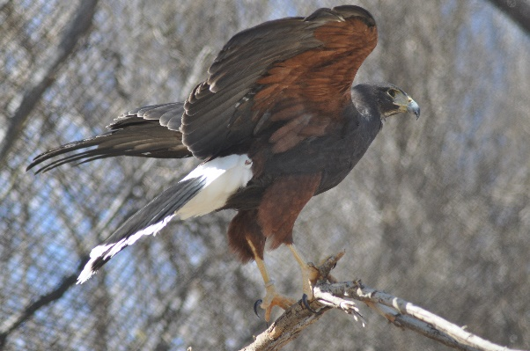
likely to see.

Harris Hawk

