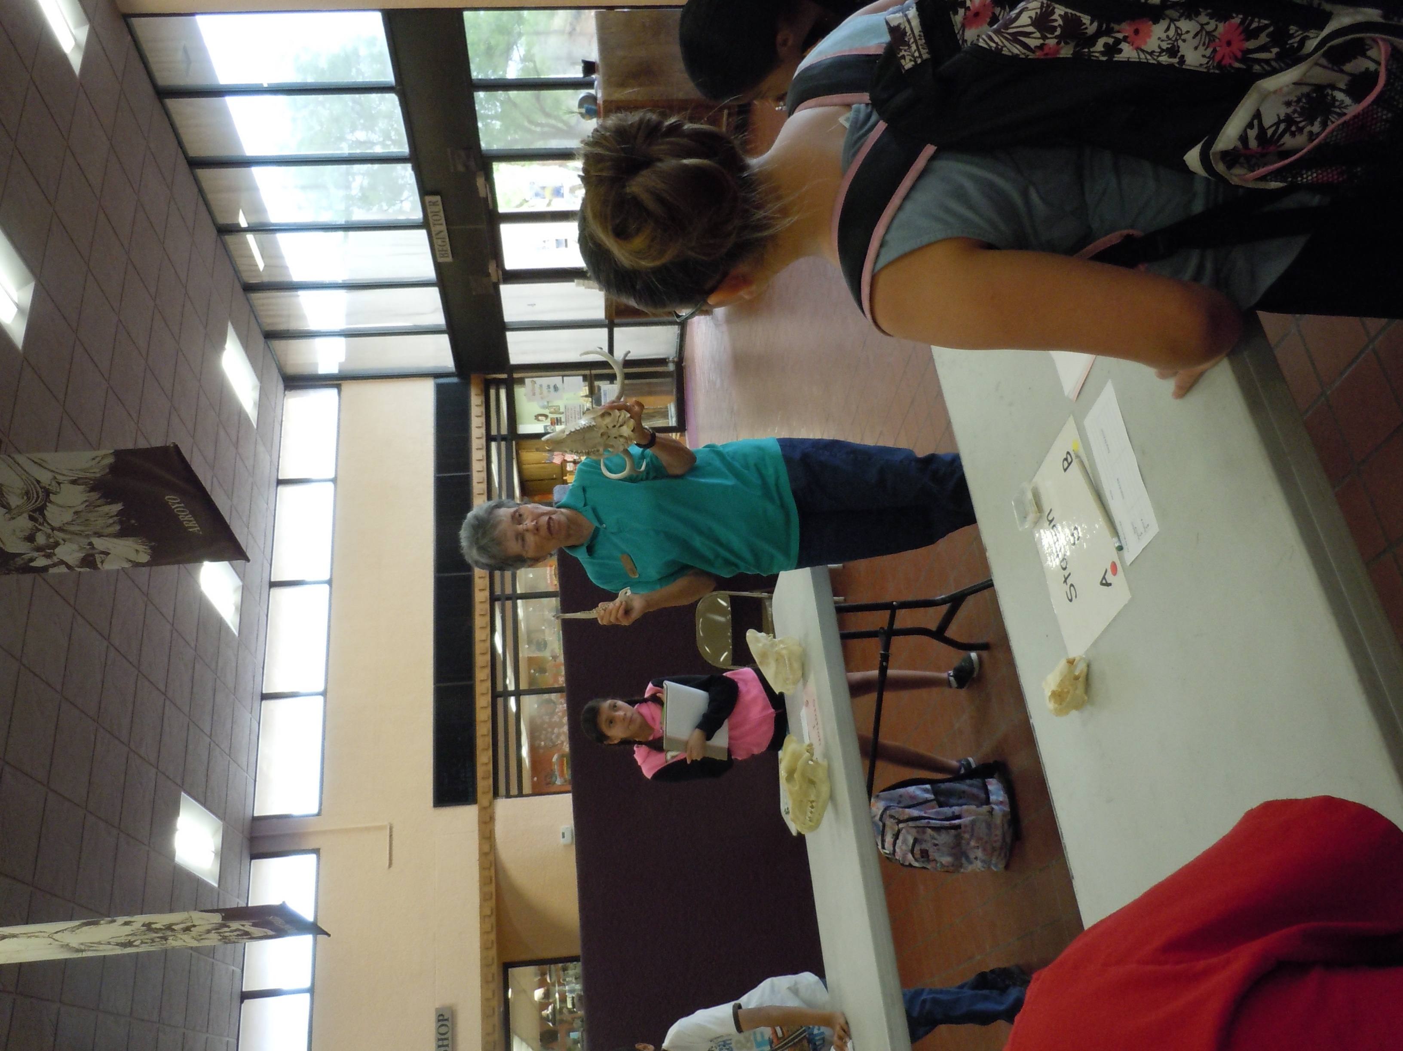
Outreach
- Several of our docents are available for outreach programs to schools, scouts, and other educational groups (including adults). Please call to reserve one of our programs. We are also willing to develop a new Chihuahuan Desert program if we have enough time.
Some developed programs are:
- Bird Beaks-The students will determine the species and diet of Chihuahuan Desert birds by examining the function and shapes of “human” tools that replicate birds’ bills and comparing them to pictures of birds. 4th grade and up
- You Are What You Eat- Students will examine the teeth of various mammals to determine if an animal is an herbivore, carnivore, or omnivore. 4th grade and up
- CSI: Who Killed the Rabbit? Students will determine which Chihuahuan Desert mammal killed the rabbit using the animals’ physical and behavioral adaptations. 3rd grade and up
- Mexican Gray Wolves- Students will view a PowerPoint to learn facts and the importance of Mexican Gray Wolves. They will also examine a skull to understand the adaptations of wolves and a foot print of this endangered species. 1st grade and up
- Food Chain or Food Web of the Chihuahuan Desert- Students will view a PowerPoint about Food Chains or Food Webs and then using pictures and a booklet of plants and animals of our desert make food chains or food webs. 3rd grade and up
- Endangered and Threatened Species- Students will become aware of why some plants and animals are threatened or endangered and learn about the endangered animals housed at the Living Desert. This program uses a PowerPoint and some animal pelts. 3rd grade and up
- Animals of the Chihuahuan Desert- Students will learn about the behaviors, diets, etc. of some or our animals. 1st -3rd grades

