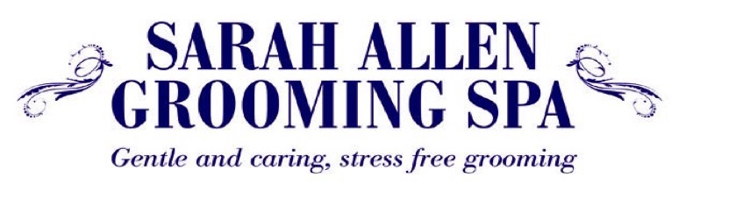
COVID 19 - Best Practise Procedure 5th January 2021

This is our protocol for dropping off and collecting your dog/s, now and in the foreseeable future.

Social distancing is compulsive – if you do not comply we will not groom your dog.

Your dog should be walked to the salon as part of your daily exercise by one member of your household then, collected by another member as part of their daily exercise or shopping trip if using your car.

All grooms are for the health & welfare of your dog, we are unable to groom your dog for any other reason.

You are not allowed to come into the grooming salon and must remain outside.

Please,

- Wear a mask if you are able to do so.
- Entrance is at the rear of 35 High Street. Knock on the glass window of the back door and move back out to the pavement.
- There is a slip lead attached to the drainpipe. Place the slip lead around your dog’s neck and tighten, please them remove your dog’s own collar, harness and lead & take them home with you. Please then stand back on the pavement but keep talking and reassuring your dog.
- Marie or myself, in PPE, will then come out of the back door and greet your dog. You can have a quick discussion, remaining at least 2 meters away.
- Marie or myself will advise you when your dog is ready for collection at the time of dropping off. Please DO NOT BE LATE, another dog will be due in and we do not want to create a gathering. If the time changes we will ring you.
- When you arrive for collection, please knock on the glass window and return to the pavement.
- Marie or myself will come out and place your dog on our slip lead attached to the drainpipe. Firstly then put on your dog’s collar, lead and harness once your dog is secure via their collar, lead & harness only then remove our slip lead.

8. We will be using ‘animal’ safe disinfectants through out the grooming process.

Payment will be taken via card machine or cash at the time of collection.

I hope this makes sense; it’s about protecting you, your family, your dogs, my staff and most importantly the NHS.
Thank you for your co-operation, Please keep safe and well.

Sarah

