Kirkus Review:
“The author’s experience as a rescue volunteer gives an air of authenticity to her descriptions of shelter work and the sensitive attention given to animals in a well-run no-kill facility. And, of course, readers will find the pups entertaining. A Whodunit with a promising premise and likeable characters.”
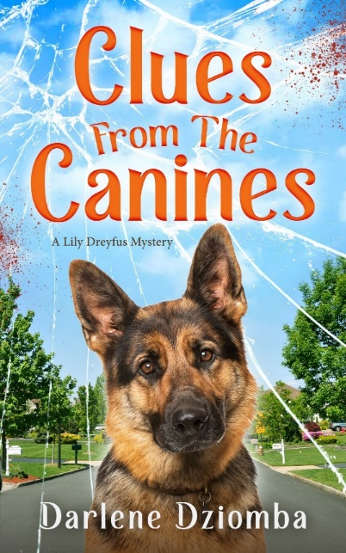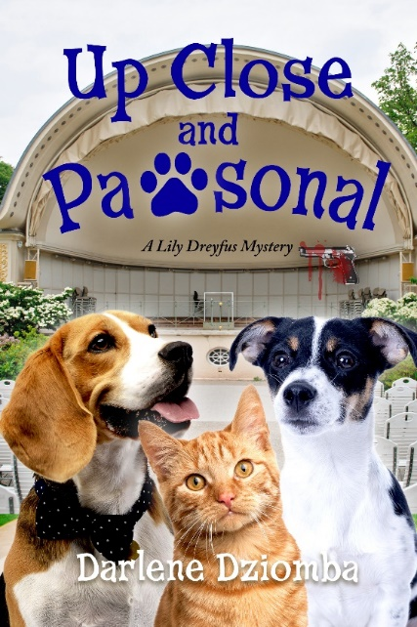
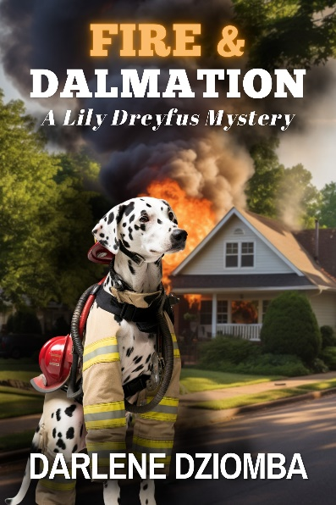

A Note From Darlene:
I am a lifelong reader and lover of mysteries. As a dog lover, I volunteer at the shelter where I adopted two rescues: a beagle, Bassett hound mix I named Tugger and a terrier mix I named Billie.
Thirty years ago, a group of librarians invited me to join a mystery book group, opening my mind to a world of books I had never imagined and introducing me to Mystery Fan Conferences.
At Bouchercon, the largest mystery fan conference in the world, I realized that I had never read a mystery in which the protagonist worked at an animal shelter. In a crazy instant, I decided to write that story.
I had a very tall mountain to climb in learning to write a book. It took many years of trial and error, much advice from other writers and librarians, and a great deal of courage. However, in 2022 I self-published Clues From The Canines.
In 2023 I released the sequel Up Close And Pawsonal in which I incorporated the knowledge gained from my thirty-year career in Finance. Fire and Dalmatian will release in 2024 and Assault and Gobblery will release in 2025.
Since publication, I have served on panels at Bouchercon, Malice Domestic and Killer Nashville. In 2024 I will be a Director on the board of SinC Grand Canyon Writers.
I am eager to share my volunteer experience at the Animal Welfare Association and my path to publication with readers. Please accept this media kit which includes discussion questions and cute photos of Billie and Tugger.
Thank you.
Author Information

Interviews:
https://amypendino.com/blog/f/looking-for-a-great-summer-read
https://lynnslaughter.com/2023/03/10/combining-her-love-of-mysteries-and-dogs-meet-author-darlene-dziomba/
https://joanneguidoccio.com/2023/01/30/follow-the-clues-to-act-2/
https://gdcramer.com/2022/04/25/darlene-dziomba/

Podcasts:
https://sites.libsyn.com/458199/special-guest-darlene-dziomba

Social Media:
www.ReadDarlene.com
instagram.com/ReadDarlene.7
facebook.com/read.darlene.7
@ReadDarlene1
ReadDarlene@hotmail.com

Buy Link:
https://www.amazon.com/stores/Darlene-Dziomba/author

Discussion Questions
- What duties did you perform as a volunteer at the Animal Welfare Association?
- How did you acquire the level of detail related to the operations of an animal shelter?
- Which of the characters in the series are modeled after people who worked at the Animal Welfare Association? Why did you choose those people as characters?
- Is there a character in the series modeled after you? Why did you choose that character for yourself?
- Clues From The Canines makes many references to flowers and gardening. Are you an avid gardener? Why was it important to you to use these descriptors in your books?
- Is it significant that Lily and her sisters have plant based names?
- The towns in which Lily and her friends live are fictional, yet you mix real places in New Jersey into the story. Why use both?
- Why did you introduce a cat character in Up Close And Pawsonal?
- Do the people in your life, who you have chosen to model into characters, recognize themselves? Do they like how you created them?
- How many books do you have planned for the series?

The Inspiration:
Animal Welfare Association
AWANJ.org

