Introduction
“Spread love everywhere you go.” Saint Teresa of Calcutta
The year is 1997 and the world has lost one of the most iconic leaders of the 20th century. In a century which included two world wars, numerous inventions and the greatest growth in corporate wealth led primarily by iconic male inventors and military, political and business leaders, arguably none spread more of God’s love around the world than a diminutive woman from Albania known then as Mother Teresa.
Reading this in the 21st century when a push for gender equality has opened more doors for women may diminish the irony, but over two thousand years prior, the foundation for great women was established by a young woman we know as Mary of Nazareth. Her obedience to God’s call to be the mother of our savior, Jesus, made her queen of heaven and earth since traditionally queens were the mother of the king.
If the fact that the greatest purely human was a woman surprises anyone, perhaps the words of a great Catholic contemporary of Mother Teresa’s said it best.
“Women possess feminine genius.” Saint John Paul II
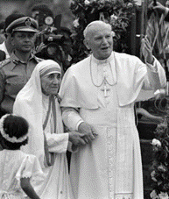
The two would both receive the designation of Saint by the Catholic church and Mother Teresa, would forever be known as St. Teresa of Calcutta. The Catholic church would add a poor town in India to this iconic woman’s name not because it was where she was born but where she shared God’s love with the poorest of the poor while struggling her faith. Yes, this Noble Peace Prize winner and iconic saint did not stop loving others even while she struggled with her faith!
The other powers sisters profiled represent the diverse influence religious women have had on education, healthcare, social justice, and the Catholic church. Although it is impossible to capture all past and current influencers, these imperfect women represent a cross-section of orders who have answered their vocational call and changed the world in service to God.
Religious sisters have founded schools, hospitals, monasteries, and religious orders to support many Catholics along their journey to develop a strong mind, body, and soul. Our healthcare and educational systems would not be the same without their influence.
Appropriately in the year that Pope Francis gave women the unprecedented right to vote at a meeting of bishops, Power Sisters recognizes the contributions religious sisters have and continue to make. With four deceased sisters profiled along with eight living, the hope is to bridge the influencers of the past with those of the present as women gain greater decision-making responsibilities within the Catholic church.

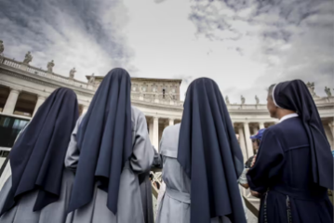
All Christians can draw wisdom and strength from these women and Mary our mother in heaven. The specifics on new voting rights for the synod include:
- Five religious sisters joining five priests as voting representatives for religious orders
- Women making up half of the seventy non-bishop voting members
Before diving into these amazing stories, it is worth briefly clarifying the history and role of religious sisters. The consecrated life has been part of religion even before the time of Christ. Since many of Christ’s disciples were women the role continued in the church he established evolving over the centuries.
Transcending the established norms of his time, Jesus treated women with openness, respect, acceptance, and tenderness. In this way He honored the dignity which women have always possessed according to God’s plan.
At Christ’s crucifixion some of those women showed that their gender had the power and hearts to carry on His message of love and mercy. While His apostle and first Pope was denying Him three times, three women accompanied his mother at the foot of the cross.
“Standing by the cross of Jesus were his mother, his mother's sister, Mary the wife of Clopas, and Mary Magdalene” John 19:25
Ciphering through the thousands of women who have followed the call to serve in a religious vocation proved challenging. The twelve religious sisters featured represent the women past, present, and future who by the grace of the Holy Spirit have made and will make a powerful impact on many along their journey to bring Christ to the world. From the poorest of the poor to the wealthiest Christians, power sisters have and will bring the special love and mercy exemplified by Jesus.
As background, both nuns and sisters are typically addressed as Sisters but there are some differences. Nuns’ lives are generally spent in prayer and work within their convent or monastery while Sisters are more active in the world, engaging in many kinds of work. Some of these power sisters blur those lines, but all have made vows to serve faithfully.
Although no single book can summarize the great achievements of all Catholic sisters over the years, this author humbly prays that these stories may inspire more in the future and shares with gratitude.
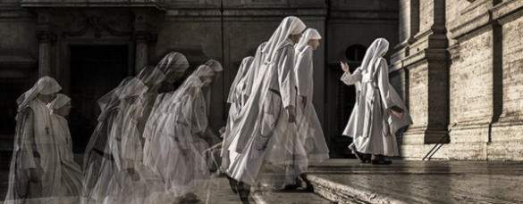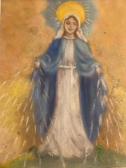

Oh, The Love and Mercy a Sister Shall Bestow

Oh, the love and mercy you shall bestow!
There is much to be done!
There are souls to be saved and hearts to be won.
And the amazing things you can do with God’s call,
will help bring His loving message to all.

Amen! You'll be as powerful as a woman can be,
with many followers online, in the classroom or TV.

You have brains in your head. You have feet in your shoes.
God can steer you any direction He
or your Mother superior may choose.
And when you're guiding young sheep as a teacher, nurse, or nun
you'll pray often to God and perhaps suffer some like his Son.

You were pioneers in the fields of education and healthcare.
Spreading the message of God to students everywhere
While opening the first hospitals for everyone’s health
Doing it all for love, not for your personal wealth

Today is the Lord’s day!
His people are waiting.
So please get on your way!
Out there, things can happen, and frequently do,
To people as trained and holy as you.
Don’t fear when bad things happen
since God will get you through.
Just lean on your faith, and His glory will shine true!

Your mission is to show God’s mercy.
The real example of power, to all those in need
Following Mary’s example of obedience and love
Using your feminine genius to plant that seed.

After your journey in this life
By God’s grace you will be old
May you come to a place where the streets are of gold,
And the holy choir of angels will be much to behold.

With the Father, Son, and Holy Spirit
His followers in heaven will be as one.
Thanks to a caring Sister they learned,
Through Jesus and the cross, the battle was won.

Greg Hendry 2023
Each chapter will end with a faith and works challenge, and in that spirit all are welcomed to join in Serra International members in a Prayer for the Perseverance of Vocations with particular focus on religious sisters.
O God, You have constituted your only begotten Son Supreme and Eternal Priest for the glory of Your Majesty and for the salvation of mankind. Grant that those whom He has chosen ministers and dispensers of His Mysteries may be found faithful in fulfilling the ministry they have received.

