ABSTRACTS FOR ORAL PRESENTATIONS

The abstract may be up to 1 page of A4 (or US ‘Letter’) long. There should be a 2.5 cm (1 inch) margin on all sides of the page. Use a 12-point Times New Roman font for the text. Set the language to English (United Kingdom), and spell-check your abstract. Submissions should be limited to 300 words without references. Please indicate clearly the objectives, scope, and results (if available) of the research or project.

Your abstract must include the following:
• Presentation title (Times New Roman, bold type, 14-point font, centred, use Title Case)
• Author names (11-point font; first name, middle initial, last name; 1, 2, 3 superscripts etc. to match addresses).
• Presenting author should be indicated in bold type.
• Presenting author e-mail address in italics, 11-point font (online before the list of co-authors).
• List of other contributing authors separated by commas, with superscript matching addresses.
• ¹Author addresses in italics, 11-point font, include e-mail for presenting author only.
• Text (12-point Times New Roman font)
Introduction of the research or project theme (1 paragraph)
Methods (analytical or calculation conditions; 1 paragraph)
Results and Interpretation (supported by data) (1 or more paragraphs)
Conclusion (1 paragraph)
• Figures or tables may be embedded in the text. Best if placed in a Text Box. Figure captions should be no less than 9-point Times New Roman font, also within the Text Box.
• A short list of references may be placed at the bottom of the page. These should be in 9-point Times New Roman font and referenced in the text using numbered superscripts.
Figure
Line diagrams and grayscale drawings must have a resolution of at least 600 dpi.
Photographs (halftones) must have a resolution of at least 300 dpi.

Save the abstract as a .pdf for submission.

Sample Abstract Format Shown Below
Title in Title Case
Name Surname¹, Name Surname¹ and Name Surname²,

First author@institution mail
¹University, Department, State/Province, Postal code, Country
²University, Department, State/Province, Postal code, Country

Introductory paragraph: Authors shall submit carefully written and proofread material. All the references should be written as APA guidelines¹, internet references should be reported based on the format indicated on Reference section² (1 paragraph).
Methods used were designed to investigate ……... All acronyms for analytical instruments and methods must be spelt out on first use. All instruments and/or software should be indicated (1 paragraph).
Results, should be explained clearly, with coherence and consistency. One Figure (or Table) below could be optional (1 paragraph).
Conclusions, this work demonstrates ……………. It introduces the topic, tells us why you are studying it, how you studied it, present major results, and what you think they mean. The conclusion is that we would all love to come to hear your talk (1 paragraph).

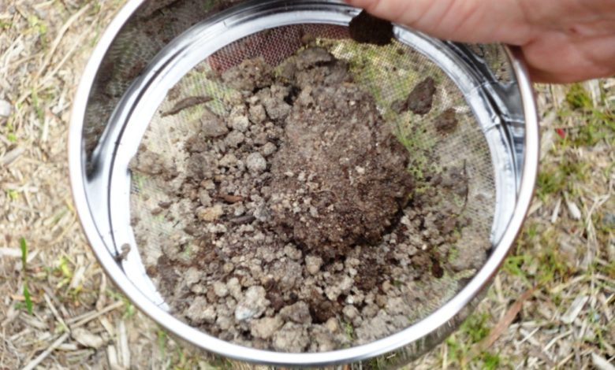
Figure 1. Soil sampling is a basic technique of mineral exploration. Cheaper than drilling, sampling can be used to quickly establish the existence and extent of hoped for mineralisation. Image reproduced from 'Geology for investors' (https://www.geologyforinvestors.com/rock-and-soil-sampling-the-key-to-most-exploration-projects/).

Acknowledgements: Authors can acknowledge funding institutions and projects indicating the reference of the grants, as follows:
The authors acknowledge the funds of XXXXX...
This work has benefited from financial support by the XXX, project XXX CEECInd/0154875215/2021; contract

References
A few references are permitted at the end of the abstract and they should be formatted as follows:
¹ Adams, D. (1979) A hitchhiker’s guide to the galaxy, Earth & Space Cadet, 204: 151-165
² Author surname, name. (2015, date). Title [Online]. Available: http://www..........

