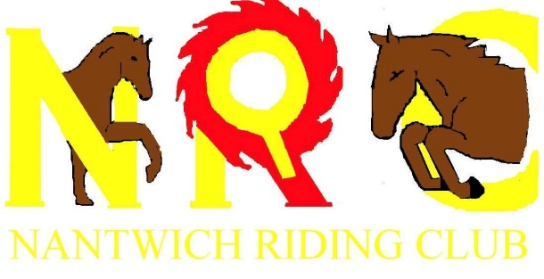
Nantwich Riding Club
Health and Safety Statement

- The organizer has overall responsibility for Health and Safety

- The event is organised in accordance with Health and Safety Legislation and all who have, to any extent, control of the premises, or site on which the event are responsible for ensuring that:
- Everything reasonably practicable is done to ensure health, safety and welfare of those attending the event.
- They conduct themselves so that they do not put themselves or anyone else at risk.
- The access to and egress from the site is safe and unobstructed.

- Emergencies
- Emergency services must have access to all parts of the event site at all times and members of the public must not park vehicles so as to obstruct access.
- First aid points are clearly marked.
- In the case of an emergency, members of the public should contact the nearest official or dial 999.
- Horses
Horses can easily be frightened and can be dangerous. Members of the public are requested to keep clear from horse areas/lanes and to avoid behaviour that might alarm horses.

- Dogs
Dogs should be kept under close control and on a short lead. The dangerous dogs act now covers private land (nov 2014).

