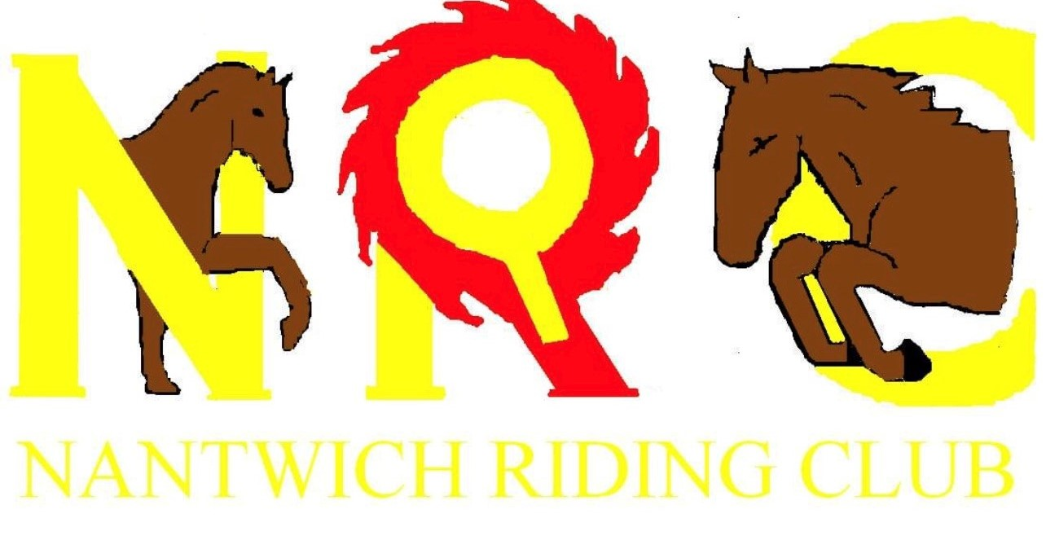
Summer Points Showing Schedules
Dates
Sunday 10th July 2022 – NCPA POYS Qualifier – All classes on this day are a NCPA POYS Qualifier
By kind permission of the Davenport Family.
Sunday 21st August 2022
By kind permission of the Dodd Family.
Sunday 11th September 2022
By kind permission of the Maughan family.
All entries are via Entry master and will strictly close the Wednesday. No late entries will be permitted, and no entries will be accepted on the day.

Entry Fees
Members £4.00per class
Non members £8.00per class.
Nantwich Riding Club is proud to be part of Stars Champions of Champions- classes that are qualifiers for Stars will have (S) next to the class. Overall points winner will be invited to represent NRC at Aintree. To qualify, you must be a member and must attend 3 out of the 4 shows.
Nantwich Riding Club is affiliated with Midland Association of Riding Clubs for 2022. Championship information to follow.
NEW FOR 2022 MEMBERS GOLDEN TICKET CHAMPIONSHIP
Each judge at each show will be allowed to award four golden tickets (maximum) to members only who then will be eligible to attend the members golden ticket supreme championship held on 11th September 2022.
&
NEW FOR 2022 MEMBERS SUPREME
At the end of each show every member who has gained a 1st place in any class will be asked to attend the members supreme of show championship.

Nantwich Riding Club Chair lady Lisa Cadman - 07792943096
Showing enquiries contact Bridget Millar-Mills – 07909338692
Qualifiers and general showing enquiries contact Katie Donnelly – 07714659493

Ring one
Ridden Showing & Equitation classes
10am Start

Class 1. Best Turned Out (S)
Class 2. Ridden ROR (S)
Class 3. Ridden Plaited Coloured (S)
Class 4a. Ridden Native / Cob/ Traditional Coloured Cob (S) Class 4b. Ridden Show Rob (S) – NOTE THESE WILL COMPETE TOGETHER BUT BE PLACED SEPRATELEY
Class 5. Ridden Veteran (S) For Stars classes will be split into the two age groups.
Class 6. Ridden Show hunter and ridden show hunter pony (Split horses / ponies) (S)
Class 7. Ridden Show horse / pony – class will be split if sufficient entries. (S)
Class 8. Ridden M&M – Split small and large breeds for placings(S)
Class 9. Junior equitation, riders under 18 years (S)
Class 10. Senior equitation, riders over 18 years

CHAMPIONSHIP
For all those placed 1st & 2nd in classes 1-10 are welcome forward.

LUNCH BREAK

Class 11. Novice In hand
Class 12. In hand Veteran (S)
Class 13. In hand Plaited horse / Pony (S) – class split if sufficient entries
Class 14. In hand coloured horse / pony (S)– class split if sufficient entries
Class 15. In Hand Bonnie Pony (S)
Class 16. In hand M&M Small & Large Breeds (S) - Class split if sufficient entries
Class 17. In Hand Thelwell Pony Type
Class 18. Junior Handler – competitors 12- 18 years (S)

CHAMPIONSHIP
For all those placed 1st & 2nd in classes 11-18 are welcome forward.

Ring Two
Family Ring Ridden and In Hand
10.30am Start
Class 19. Green Horse or returning to showing.
Class 20. Novice or Nervous rider (open to any rider 12 +)
Class 21. Golden Oldies (40 years and older).
Class 22. Pony with the cheekiest face (Competitors 8 years & under)
Class 23. Handsome gelding / prettiest mare (Competitors 8 years & under)
Class 24. Best mane & tail (Competitors 8 years & under)
Class 25. Best walk and trot (Competitors 12 years & under)
Class 26. Best ridden figure of eight in trot (Competitors 12 years & under)
Class 27. The Best combination (Competitors 12 years & under)
CHAMPIONSHIP
For all those placed 1st & 2nd in classes 18-27 is welcome forward.

LUNCH BREAK

Class 28. Tiny tots handler – competitors 6 years & under (S)
Class 29. Young handler – competitors 8-11 years (S)
Class 30. Lead Rein equitation, riders 8 years & under (S)
Class 31.First ridden equitation, riders 10 & years under
Class 32a. Lead Rein Plaited Pony (S) Class 32b Lead Rein M&M (S) NOTE THESE WILL COMPETE TOGETHER BUT BE PLACED SEPRATELEY
Class 33. First Ridden (riders 10 years and under) (S)
Class 34. Riding club horse / pony (Split if sufficient entries) (S)

CHAMPIONSHIP
For all those placed 1st & 2nd in classes 28-34 is welcome forward.

Ring Three
Working Hunter
Classes start 9.30am
Class 35. Poles on the floor working hunter open to on and off the lead rein – competitors 12 years & under
Class 36. Tiny X poles working hunter not exceeding 20cm open to on and off the lead rein. Competitors 12 years & under
Class 37. Next steps working hunter not to exceeding 30cm off the lead rein. Competitors 12 years & under.
Class 38. Lead Rein Working Hunter. 30-40cm Riders to be age 10 & under and pony under 128cm. (S)
Class 39 Junior Beginners Working Hunter jumps not exceeding 40cm
Class 40.Tiny tots working hunters 40-50cm – riders to be age 10 years and under and pony under 128cm (S)

Any under 12 combinations that have competed in classes 35 to 40 cannot compete in classes 41-49. Classes 35-37 are over a shortened course.

CHAMPIONSHIP
For all those placed 1st & 2nd in classes 35-40 is welcome forward.

LUNCH BREAK
Class 41. Pre Novice Working Hunter jumps not exceeding 50cm – class split juniors / seniors if sufficient entries.
Class 42. Novice Working Hunter jumps not exceeding 60cm – class split juniors / seniors if sufficient entries.
Class 43. WHP 133cm and under 65cm. (S)
Class 44. M&M Small Breeds WHP 60cm. (S)
Class 45. WHP exceeding 133cm but not exceeding 153cm 75cm. (S)
Class 46. M&M Large breeds WHP 75cm (S)
Class 47. Working Hunter Style and Performance – to be judged on jumping section only, jumps not exceeding 80cm. class split juniors / seniors if sufficient entries.
Class 48. Open working Hunter not exceeding 153cm 90cm
Class 49. Open Working hunter exceeding 153cm 90cm. (S)
CHAMPIONSHIP
For all those placed 1st & 2nd in classes 41-49 is welcome forward.

MEMBERS SUPREME
Any current Nantwich Riding Club members who have placed 1st in any class throughout the day are invited to the members supreme championship at the end of the day- note this will take place once all rings have finished.

MEMBERS GOLDEN TICKET CHAMPIONSHIP – Held on Sunday 11th September 2022
All those current Nantwich Riding Club Members who have gained a golden ticket are invited forward to this Members Golden Ticket Championship.

Rules
- No animals under the age of 4 are allowed to compete or be on the showground due to insurance purposes.
- All competitors mounted must always wear protective headgear-conforming to BRC standards, these must be worn with harness fastened.
- No competitor will be permitted to enter any class unless correctly dressed. If unsure, please contact a committee member of NRC who will happily provide a copy of our ring etiquette guide. Show entries will only be refunded in the event of a class being cancelled.
- The Judge’s decision in any class is final.
- Rosettes will be awarded 1st-6th Place.
- Age qualifying date for the rider is 1st January in the current year.
- Any person found to be using anti-social / abusive / bulling behaviour towards other competitors, judges, committee will be asked to leave by a member of the committee / show organisers.
- Any horse / pony misbehaving and deemed to be unsafe will be asked to leave.
- All entry fees shall be paid by the date stated on the scheduled – no late entries will be accepted under any circumstances.
- Horse / ponies must not be left tied to trailers or lorries and left unattended.
- Stallions are welcome to attend must be handled by someone who has control. Stallions must be always appropriately bitted and must wear a stallion badge.
- No skipping out of trailers or lorries on to car park- please use the correct appliances and facilities.
- Please do not leave litter.
- All equines need to be vaccinated yearly. Passports will need to be checked on arrival.
- Dogs must be kept on leads at all times and dog muck to be picked up.

