**Terms and Conditions Working with First Impressions Cleaning Services**

**Section I. Communications**

1. *Management Company* agrees to email all communication to the email provided on website under contact us page (Currently [lupenunez.firstimpressions@gmail.com](mailto:lupenunez.firstimpressions@gmail.com)). Emails are required to include basic information such as: property address, access code(s), clean date, type of service that is being requested, and any additional information pertaining to the service. ______
2. If more than ten cleans are being emailed over at once, the schedule will include the above information as well as formatted in an Excel document. Scheduled cleaning services must be communicated at least one or two days before service date (min of 18 hours). Cleaning services that require immediate attention can be requested by a phone call to the number provided on website under contact us page. Services will not be rendered without an email following phone call. ______
3. *First Impressions* agrees that emails are checked constantly and may only be replied to after 5pm. If there is any confusion with emails, questions may be imposed to management company.  ______

**Example Email Format:** 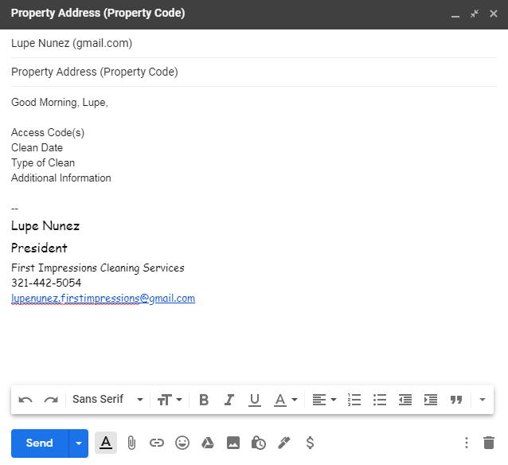

**Section II. Types of Cleans**

1. *Management Company* agrees to review the First Impressions website - Expectations page. They also agree to what is expected from First Impressions during each type of clean. Communicating any issues of the service within 24 – 48 hours of service date. ______
2. *First Impressions* agrees that cleans will be held to the standards of each type of clean scheduled and will resolve any issues that are needed within 24 - 48 hours of the service date. ______

**Section III. Expectations**

1. *Management Company* agrees to review the First Impressions website - Expectations page. They also agree to what is expected from First Impressions during a clean in specific areas. Communicating any issues within 24 – 48 hours of service date. ______
2. *First Impressions* agrees that cleans will be held to the standards of each specific area cleaned and will resolve any issues that are needed within 24 - 48 hours of the service date. ______

**Section IV. Contract Agreements**

1. *Management Company* agrees to review with First Impressions an agreed price for each “Standard Clean”. Prices may vary on unit size, location, and type of unit or client. ______
2. *Management* *Company* agrees to one of two increases in agreed prices (initial agreed option below) ______

* ___Increase charge amount by 5% each year.
* ___Management Company pays 60% of Guest’s cleaning charge reviewed bi-annually.

1. *First Impressions* agrees to review with management company on agreed unit price based on price variables. First Impressions reserves the right to decline price increase based on annual work provided by management company. ______

**Section V. Procedures**

1. *Management Company* agrees to the billable service charges in addition to cleaning charge. Every additional service charge will be communicated to management company before appearing on invoice. Every attempt to avoid service charges will be made. All types of service charges may be doubled or tripled depending on the situation’s variables. ______
2. **Service Charges**
3. Pets – An additional $50 to remove scents, hair, or dander. ______
4. Dry Runs – A service charge of $25 per property or $10 per cleaner, resulting from management company not communicating to First Impressions to cancel or adjust service. ______
5. Same Day – An additional $25 if a call is made for a clean the same day ______
6. Limited Time – An additional $25 if late checkout and back to back on service date. ______
7. After Hours – An additional $25 if a clean is required after 5pm or before 9am. ______
8. Extra Cleaning – Additional charges maybe required depending on the variables. ______
9. **Maintenance Issues Procedures**
10. Washer & Dryer – An additional $25 if cleaners must use a different unit for laundry. ______
11. Dishwasher – An additional $25 if cleaners must wash dishes by hand. ______
12. Air Condition – An additional $25 if AC is not operating inside unit. ______
13. No Power or Water – Cleaning services cannot be performed which will result in a Dry Run charge. Service will have to be rescheduled by management company. ______
14. **Housekeeping Procedures**
15. Lost & Found – Cleaners are not responsible for lost and found items; however, cleaners will do everything in their power to find items and leave near entry or counter of unit. ______
16. Stained Linen – Cleaners will do everything in their power to address stained linen, bleach will only be used if directed by management company. Items will be treated as Lost & Found. ______
17. Laundry Mat – An additional $25 charge along with the cost from laundered items. ______
18. Guest Complaint – If First Impressions is called to a complaint that is not valid for cleaning issues or unit was not cleaned within 7 days will result in a $25 charge. ______
19. *First Impressions* agrees all service charges will be communicated via email to management company representative. Charges will not be added unless validated. If discrepancies in service charges appear on invoice, First Impressions will be responsible for adjustments. Every attempt to avoid service charges will be made. First Impressions reserves the right to waive any service charge. ______

**Section VI. Paperwork**

1. *Management Company* agrees that invoices are sent from First Impressions Cleaning Services on a weekly basis. Weeks resulting in smaller amounts of scheduled work may be combined and sent bi-weekly or monthly basis. Each company can define “work week” to First Impressions. If a discrepancy in invoices-to-services provided appears, it is the responsibility of the management company to communicate discrepancies via email so that a new service invoice can be composed. All discrepancies must be validated in order to be adjusted. Direct Deposits can be made to First Impressions along with check, cash, or money order payments. ______
2. *First Impressions* agrees to send invoices at monthly minimum in accordance to work scheduled. If invoices need adjustments, First Impressions will validate adjustments and send a new invoice, voiding prior invoice for service dates. First Impressions agrees to provide via email, a copy of W-9, Business License, Liability Insurance, workman’s comp, and all agreed service contracts upon request. ______