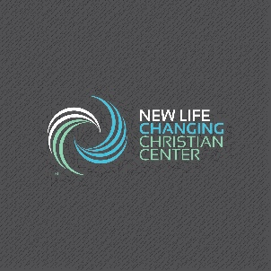

New Life Changing Christian Center, Inc.

8000 Dyson Road Brandywine, Maryland 20613

Mailing address: P.O. Box 343 Brandywine, MD 20613

(240) 412-5285

[faith@newlifechangingcc.org](mailto:faith@newlifechangingcc.org)

*New Member Application*

**Demographic Information**

Name: ______________________________________

Date of Birth: ________________

Date of Membership (ADMIN USE): _______________

Email Address: ________________________________

Marital Status: Single_____ Married ____ Divorced____ Widowed ____

Date of Marriage: _____________________

Current Address: ______________________________________

City: ______________________ State: _______________ Zip code: ____________

Phone home: _________­­­__________________ Mobile: ______________________________

**Spouse’s Information**

Spouse Name: __________________________________________

Date of Birth: _________________________

Date of Membership (ADMIN USE): __________________

Email Address: ___________________________________

Current Address (if different): ____________________________________

City: _____________________ State: _______________ Zip code: ____________

Phone home: _________­­­__________________ Mobile: ______________________________

**Dependents**

Name: _______________________________________

Date of Birth: _______________________ Male____ Female____

Date of Membership (ADMIN USE): _____________________

Name: _______________________________________

Date of Birth: _______________________ Male____ Female____

Date of Membership (ADMIN USE): _____________________

Name: _______________________________________

Date of Birth: _______________________ Male____ Female____

Date of Membership (ADMIN USE): _____________________

Name: _______________________________________

Date of Birth: _______________________ Male____ Female____

Date of Membership (ADMIN USE): _____________________

**Signatures**

Please Note: NLCCC updates member information annually. Please be sure to advise of any changes throughout the year to ensure that records remain accurate. Please send your completed application to the administration team at [faith@newlifechangingcc.org](mailto:faith@newlifechangingcc.org)

Signature: ___________­­­_________________________ Date: __________________

Spouse Signature: ___________­­­_________________________ Date: __________________